Black History Month Celebration
Earth Moves collaboration with Wirral Multicultural Organisation

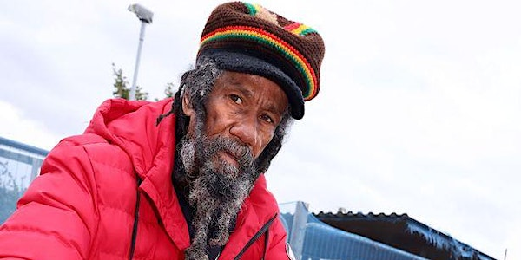

Talk by Barry Chang, an inspirational Beekeeper and screening of
his Netflix film “Bee Whisperer”.

Barry is a Jamaican-born beekeeper. He has been the heart of his local community in Liverpool for over 20 years. Barry’s highlights the importance of being outside and connecting with the natural world for our well-being and the importance of bees for growing food. Barry takes inspiration from his bees; he shares how hope and togetherness can be found in all situations. Due to his deep connection, he does not need protective clothing when tending his bees. Barry has a documentary on Netflix exploring life and wisdom.
This is a great opportunity to meet him and ask him any questions you may have.
When Tuesday 8th November 2022 Time 10.30pm-12.30pm
Venue Wirral Multicultural Centre, 111 Conway Street Birkenhead

