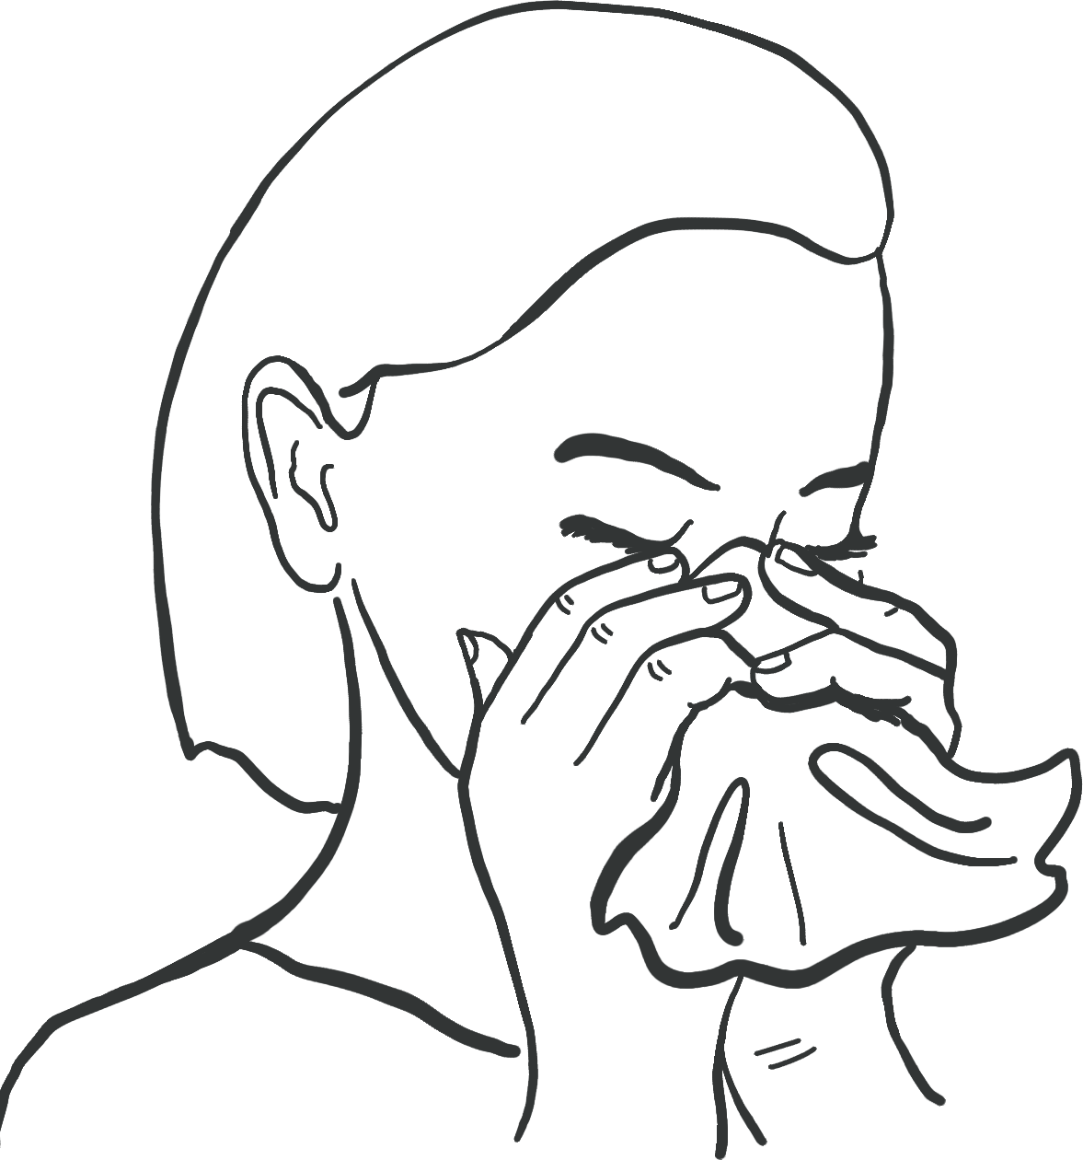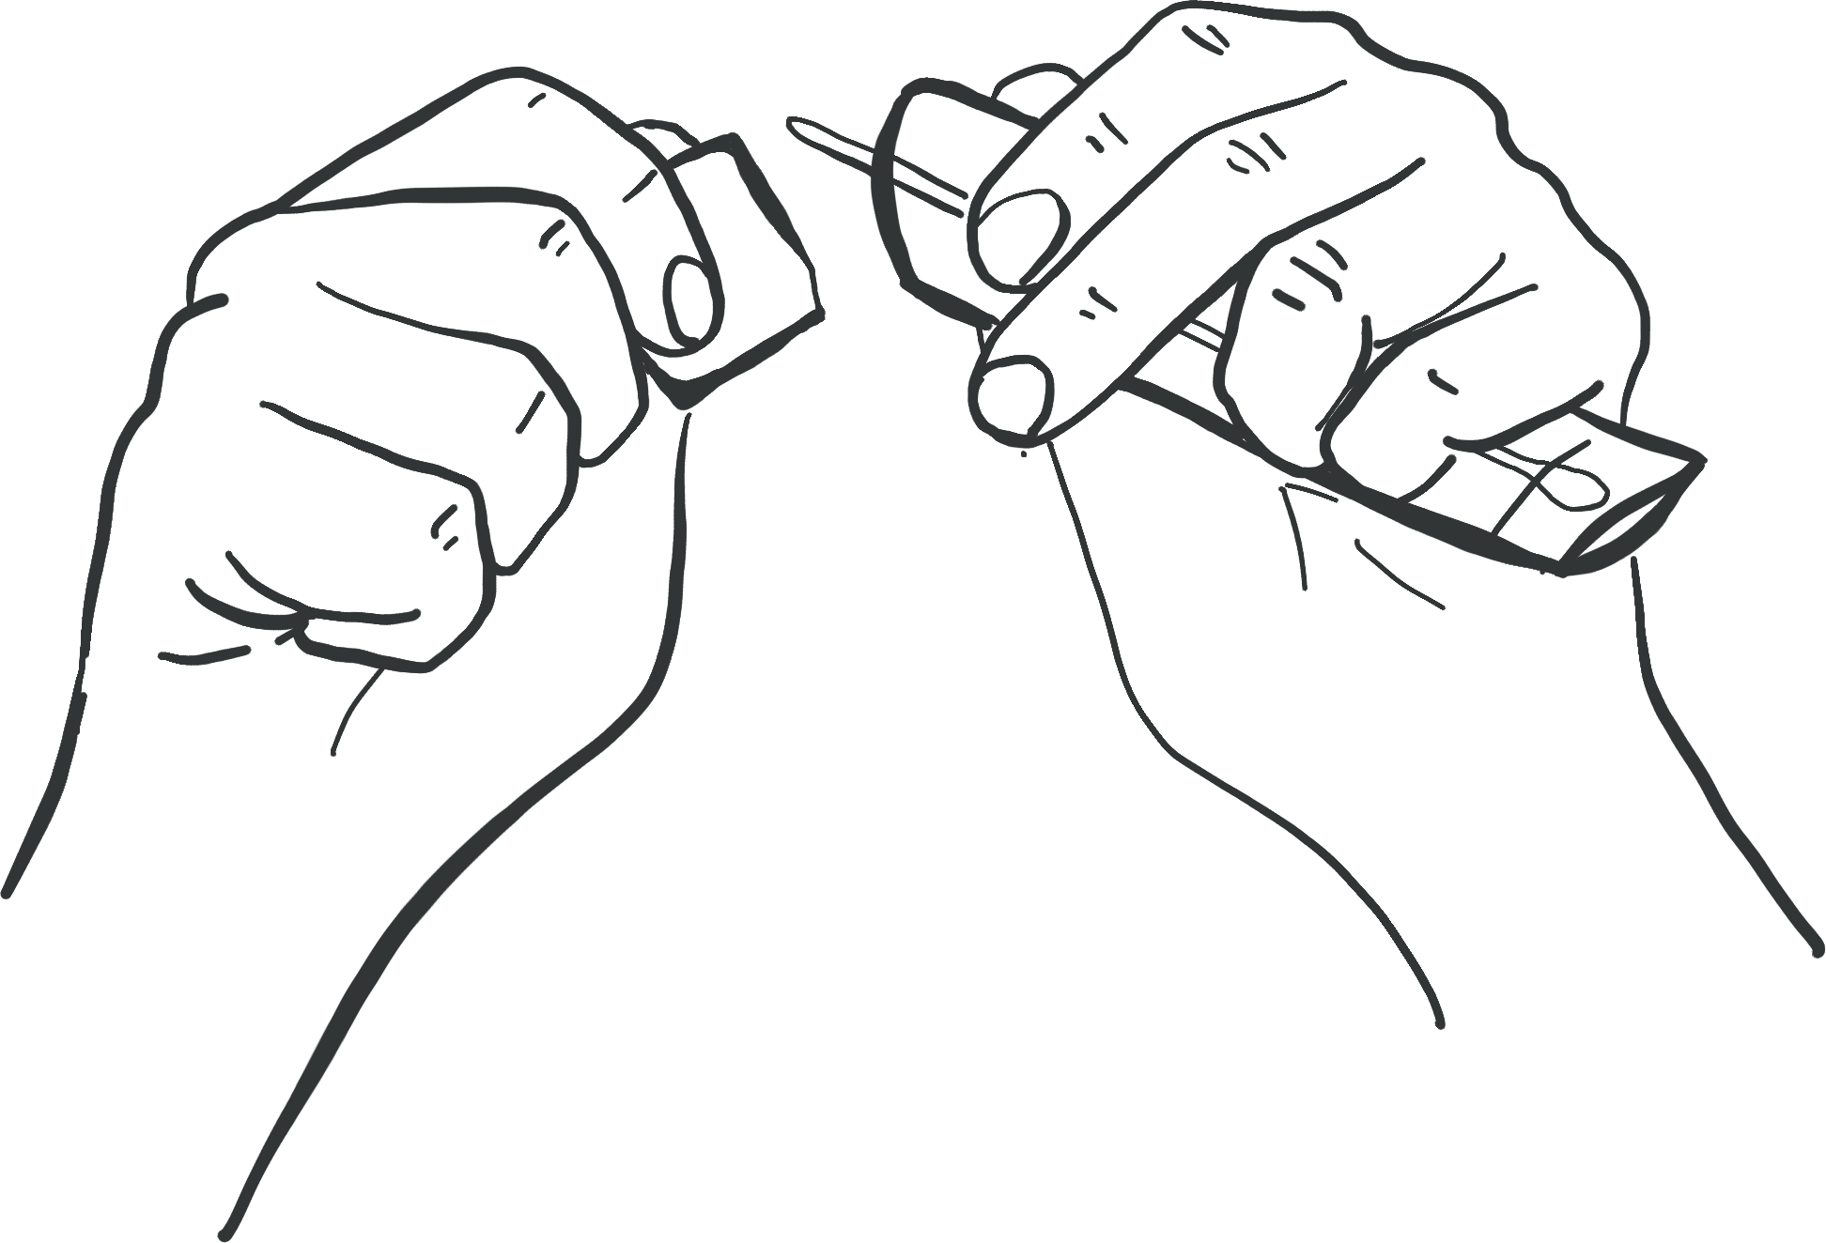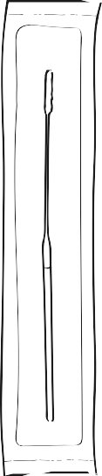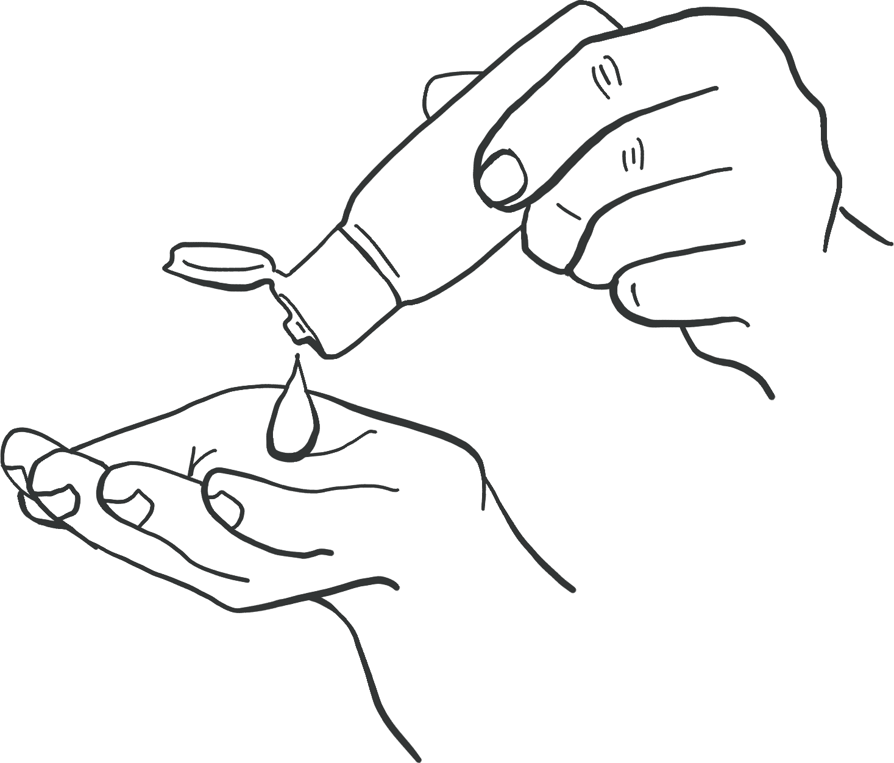

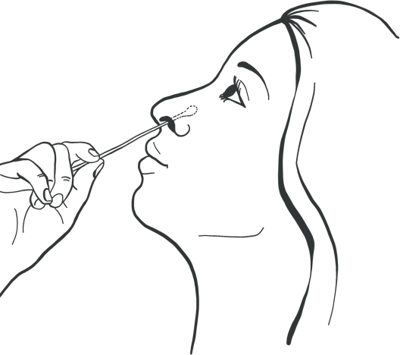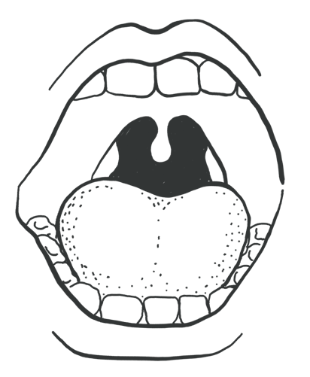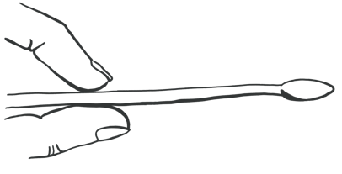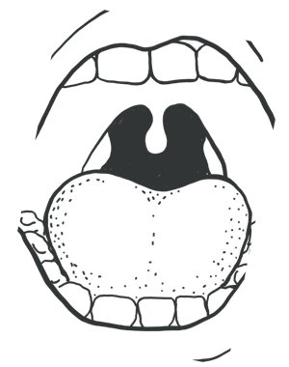

**Take swab sample**

Step-by-step guide

**1**

**6**

Remove your face covering.

**Look inside your mouth, and find your tonsils at the back of the throat.** You can use the mirror to help.

Your tonsils or where they would have been (if they are removed) are where you will swab your sample.

**10**

**secs**

Holding the swab in your hand, open your mouth wide and rub

the fabric tip of the swab over both tonsils (or where they would have been) at the back of the throat with good contact **at least 3 times**

(use a mirror to help you do this).

Carefully remove the swab stick from the back of your throat.

**2**

**Gently blow your nose into a tissue**

Throw the used tissue into the clinical waste bin provided.

This is so that you get rid of excess mucus.

**7**

**10-15**

**secs**

Put the same end of the same swab gently into one nostril until you feel a slight resistance (about 2.5cm or 1 inch up your nose).

Roll the **swab 5 times** along the the inside of the nostril.

**3**

**Use hand sanitiser to clean your hands.**

This is so that you do not contaminate the test kit.

Soft tip

**4**

**Check if there is a swab in a sealed pack in front of you.**

Identify the soft, fabric tip of the swab.

Handle

**Follow the instructions from a member of staff on what to do next.**

**5**

**Open the package and gently take out the swab.**

This will be used for both throat and nose.

**Use hand sanitiser after handing in your sample.**

TC

**Do not touch your tongue, teeth, cheeks, gums, or any other surfaces with the fabric tip of the swab.**

**The swab is invalid if it touches these parts, and you will need to get a new swab. If this happens ask a member of staff to get assistance.**

**After collecting the sample hold the swab upright in your hand, do not put it down and notify one of the Testing assistants.**

**Be careful not to touch any surfaces with the swab. Put on your face covering.**

**The swabbing may feel uncomfortable. Do not insert**

**the swab any deeper if you feel strong resistance or pain.**

**If there is blood or vomit on the swab sample, please alert a member of staff.**

**Need help?**

If you have any questions or problems with this test kit, please alert a member of staff.