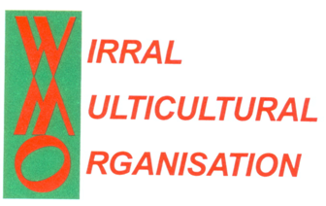



**STAY AWARE**

**BRAIN HEALTH AND YOU**



**Tuesday 21st May 2019**

**10.30am-12.00noon**

**Come along for a Dementia friendly fun day**

* Board games, matching games and bingo
* Singing
* Nostalgic Photo Display and old artefacts
* Nostalgic Vietnamese Coffee, Hong Kong Style Milk Tea & Coffee and Indian Masala Tea

Wok Tossing challenge

Join Us

Flameless

Wok Tossing Challenge

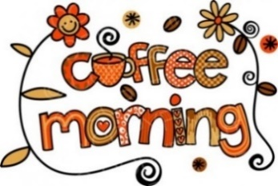

**Multicultural**



Coffee Morning

All welcome to attend

Carers are welcome

Wirral Multicultural Organisation

**111 Conway Street,**

**Birkenhead CH41 4AF**

[**Tel**](Tel:0151)**: 0151 792 5116**

[www.wmo.org.uk](http://www.wmo.org.uk)